Dear OOKs,

OOKs GNR Fundraising Update 6 – Top Ten Sponsorship Tips
With just three weeks to go, we’ve now raised £660 and are 13% of the way towards our fundraising target. With this solid start behind us, I thought it was a good time to share some top tips for raising sponsorship. I hope you find them useful!
1. Why not familiarise yourself with some of Advantage Africa’s work though our newsletter and website? Consider focusing on one aspect, project or story that you can give as an example of why you think the charity is worth supporting. If you can spare five minutes, have a look at this video from one of our projects in Uganda: https://www.youtube.com/watch?v=PJrUtB-pLH4
2. Make your communications as personal as possible as you inform your friends, family and colleagues of what you're doing and why and how their support will make a difference. Make sure your emails are to the point and not overlong (like mine often are!).
3. Share the link to the OOKs sponsorship page https://www.justgiving.com/fundraising/olneyoldknees2017gnr as widely as possible through email, Facebook and whatever other means you can. Let me know if you’d like some business cards with a link to your page to hand out when you tell people about your run.
4. Think about whether you could ask your employer to sponsor you or match-fund your fundraising efforts to help bring in one or two more substantial donations.
5. A good first donation from a family member or friend often encourages others to be generous. The average donation on the page so far is actually £41.25 thanks to some wonderful £50s and £100, including those from our very own OOKs!
6. Updates on the page (for example if you are doing some training) can also help people engaged so send anything you’d like me to put on the Just Giving page to me and I will put it on there (as long as I’m not on holiday, see below).

7. Send out a reminder to those that haven’t sponsored you just before the race and when its over - we’ve found from past events that many people sponsor at the last minute and even afterwards.
8. If you have people who prefer not to donate online and would like a good old fashioned sponsor form, I’ve attached one here. Make sure you follow up any pledges by collecting their donations shortly after the race.
9. Keep an eye on the Just Giving page to keep track of your sponsors so you can say or write a personal thank you. It’s also vitally important to let people know how you got on and thank them for their support once the race is over.

10. Remember that your efforts will make a difference. For example, because they lack the protective pigment melanin in their skin, 98% of albinos in Africa die from skin cancer before they reach 40 years. Just this morning we have sent funds for skin clinics in four districts of Uganda for people with albinism and last week we sent a consignment of 3,500 bottles of SPF 50 sunscreen to distribute at the clinics. Your fundraising for projects like these really can save and change many lives.
With thanks and best wishes,
Andrew

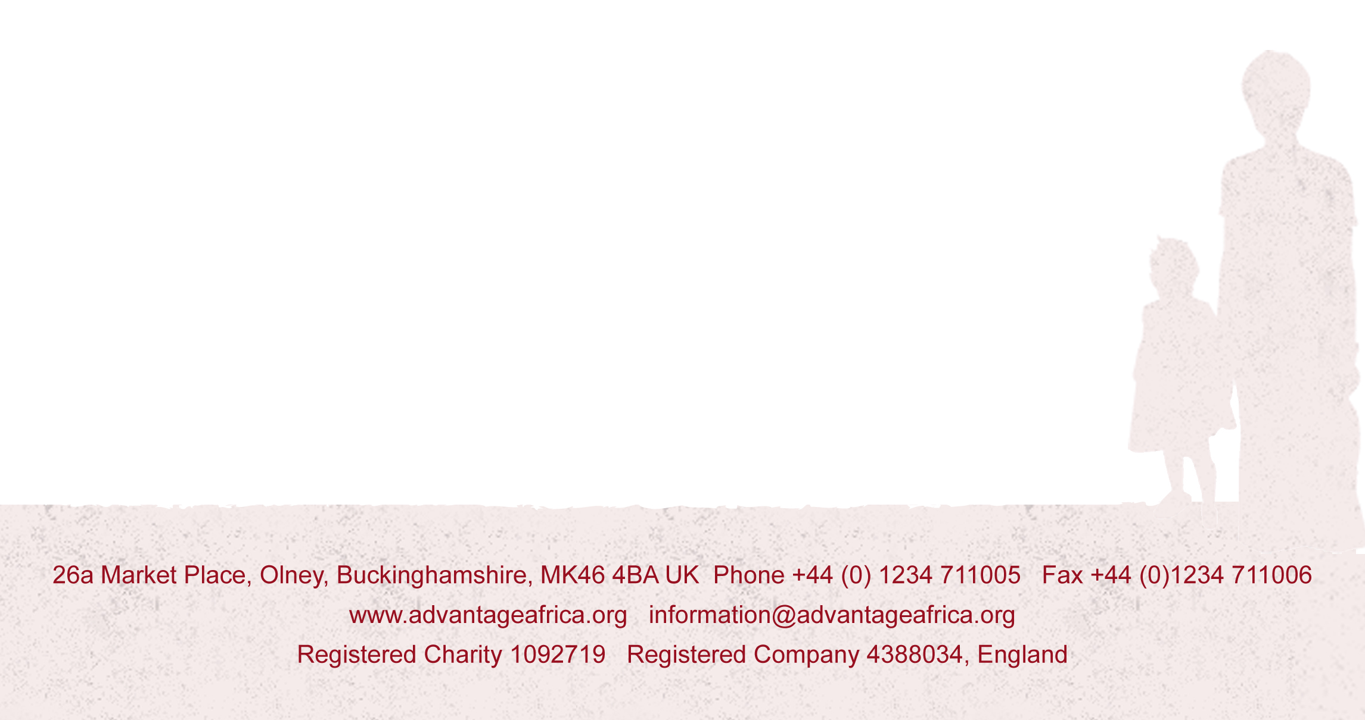
P.S. I’m trying to go on holiday on Wednesday and will be leaving my email in the office so please forgive me if I don’t answer any emails while I’m away.

