Dear all,
OOKs GNR Fundraising Update 3 – Cake, and Time to Order Your Shirts and Caps!
First of all, a big thank you to Sheila for her wonderful cake yesterday and to everyone who made a donation towards a slice. For those of you who missed it, pictures are attached for you to see. There was £45.50 in the tin which brings our total raised to date on the OOKs fundraising page to £265.50 - 5% of the way towards our £5,000 target!

Thanks to those of you who have already started sending out the link https://www.justgiving.com/fundraising/olneyoldknees2017gnr and/or donated on the page. In the next update I will include some wording which you can copy, paste and edit into an email to send to all your family, friends and colleagues.

I know it’s a long-standing tradition to get some OOKs team kit and this year we are planning to have some wickable running shirts and caps made using sublimation printing that won’t fade in the wash. The shirts even have some dashing red stripes to help you run faster, ease movement of your arms and stand out clearly from the other 60,000 runners without resorting to a rhino suit. We’ve been given a good discount and got them for £12 each. The caps are also made of similar material with a built in sweat-band and will cost £10.
To make things easier and reduce the admin I’ve set up a webpage at http://www.advantageafrica.org/ooks with an online payment widget. All the instructions, including the need to email me with your size and make sure you do NOT Gift Aid your payment, are on the page. Please order asap, and by 20th August at the latest so we can get the shirts and caps in plenty of time before the big day.

With many thanks and best wishes,

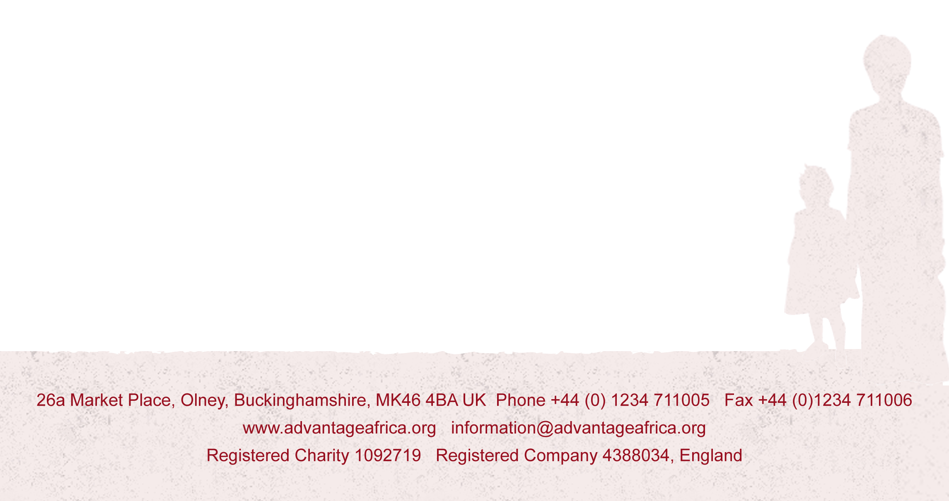
Andrew

