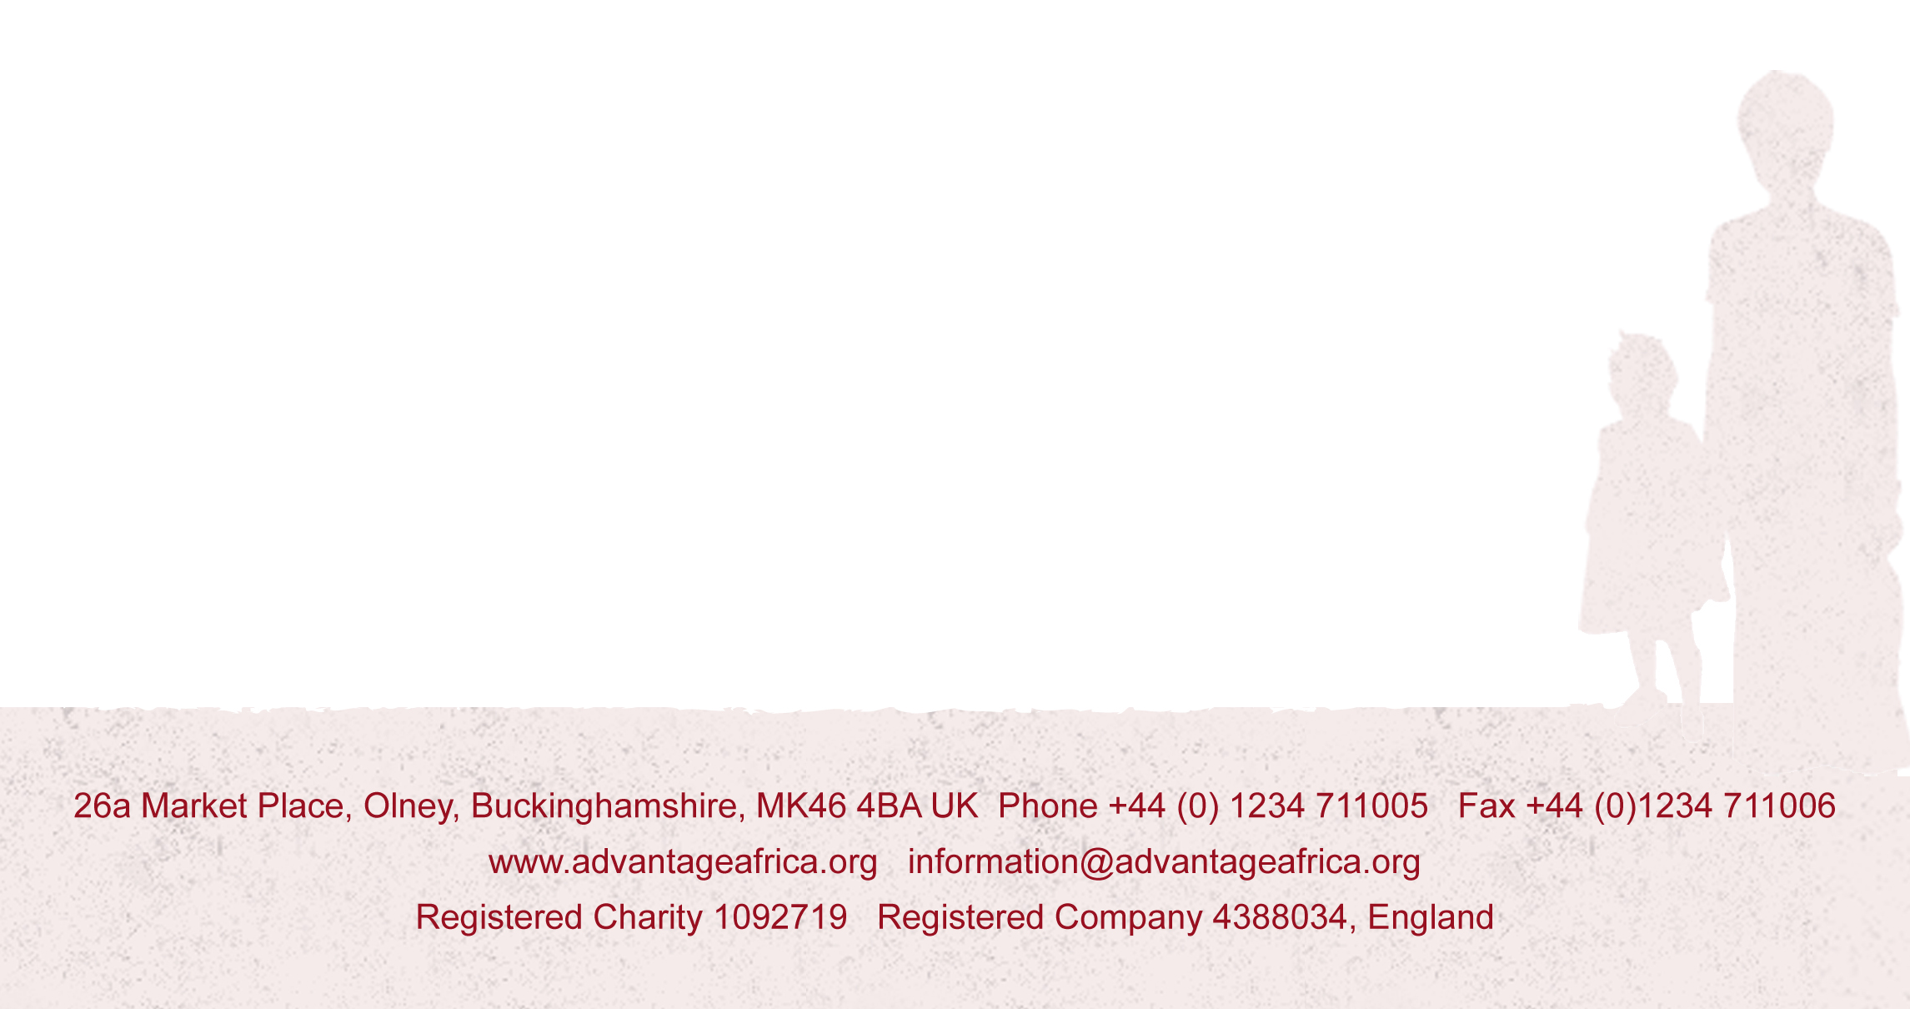

Dear all,

OOKs GNR Update 2 – Improvements to Fundraising Page and We’re Off the Mark!
I’ve put all our names on the fundraising page at https://www.justgiving.com/fundraising/olneyoldknees2017gnr although I have a feeling there may be some tweaks still needed - so please let me know if you are not actually running the Great North, not fundraising for Advantage Africa or would prefer to have your own fundraising page, so I can get this exactly right. Having your own page is absolutely fine (and what I will be doing myself because it can be made more personal to appeal to those who sponsor Jane or I most years, and so hopefully raise more money). Please forgive me if your name is Chris and I’ve had to abbreviate your surname to one letter, or Stephen and I’ve had to call you Steve, but this was needed to fit everyone into the 255 characters available - exactly!
I’ve added an update about our run on Sunday and a handful of pictures from some of Advantage Africa’s projects so that your friends and family can see the kind of work they’ll be supporting when they donate. As I mentioned in my first update, please let me know any feedback you have on the page and send me any updates about your training or fundraising you’d like me to put on there so we can keep it interesting and current.
It’s good to see that we are off the mark via Donna O’Grady (a friend of mine who picked up on an accidental Facebook share) and our very own Andrew Albrecht. Thanks Andrew and let’s hope that any other OOKs not doing the GNR but reading this email will soon follow your lead. Both Advantage Africa and those of us braving 13.1 miles on September 10th will surely be very grateful.
I’m feeling a bit guilty that everyone else seems to be up to 8 or 9 or miles or even more with their training and I’m still on 5, but aim to rectify that very soon. Anyone fancy a longer run one evening this week? Perhaps even tomorrow?
With thanks and best wishes,
Andrew

