Dear all,
OOKs GNR Fundraising Update 1 – Thank You and Sponsorship Page Launched
First of all, a big thank you for fundraising for Advantage Africa this year. My wife Jane and I who founded the charity back in 2002, really appreciate it, but most importantly so do the people we work with across Kenya and Uganda. They are children, women and men who not only face chronic poverty but also the discrimination, exclusion and even persecution that comes from living with a disability, HIV or albinism. I’ll tell you a bit more in future updates but for the moment will point you to what journalist Jon Snow says about us at https://www.youtube.com/watch?v=rTYeEyFXe1U (takes just over a minute).
I have set up a fundraising page at www.justgiving.com//OlneyOldKnees2017GNR to which I will add a few more photographs when I get a moment. I know that you’ve had one page for the whole team in the past, but if any of you think you can raise more money by having a personal page that’s also fine.
One thing that I must do is put a proper list of everyone who is doing the race on the page because at the moment it is a wholly inadequate mention of a few first names. Does anyone have a definitive list to help me out with that please?
The JustGiving page has a facility to add short updates on our training and fundraising so if any of you would like to write anything to keep the page current just email it over to me and I will cut and paste it on there. Please also let me know if you have a better picture, thoughts on the fundraising target etc
Future updates will include fundraising tips, a sample email to send to friends and family, details of hats and shirts and much more.
Thanks so much again, and best wishes,

Andrew

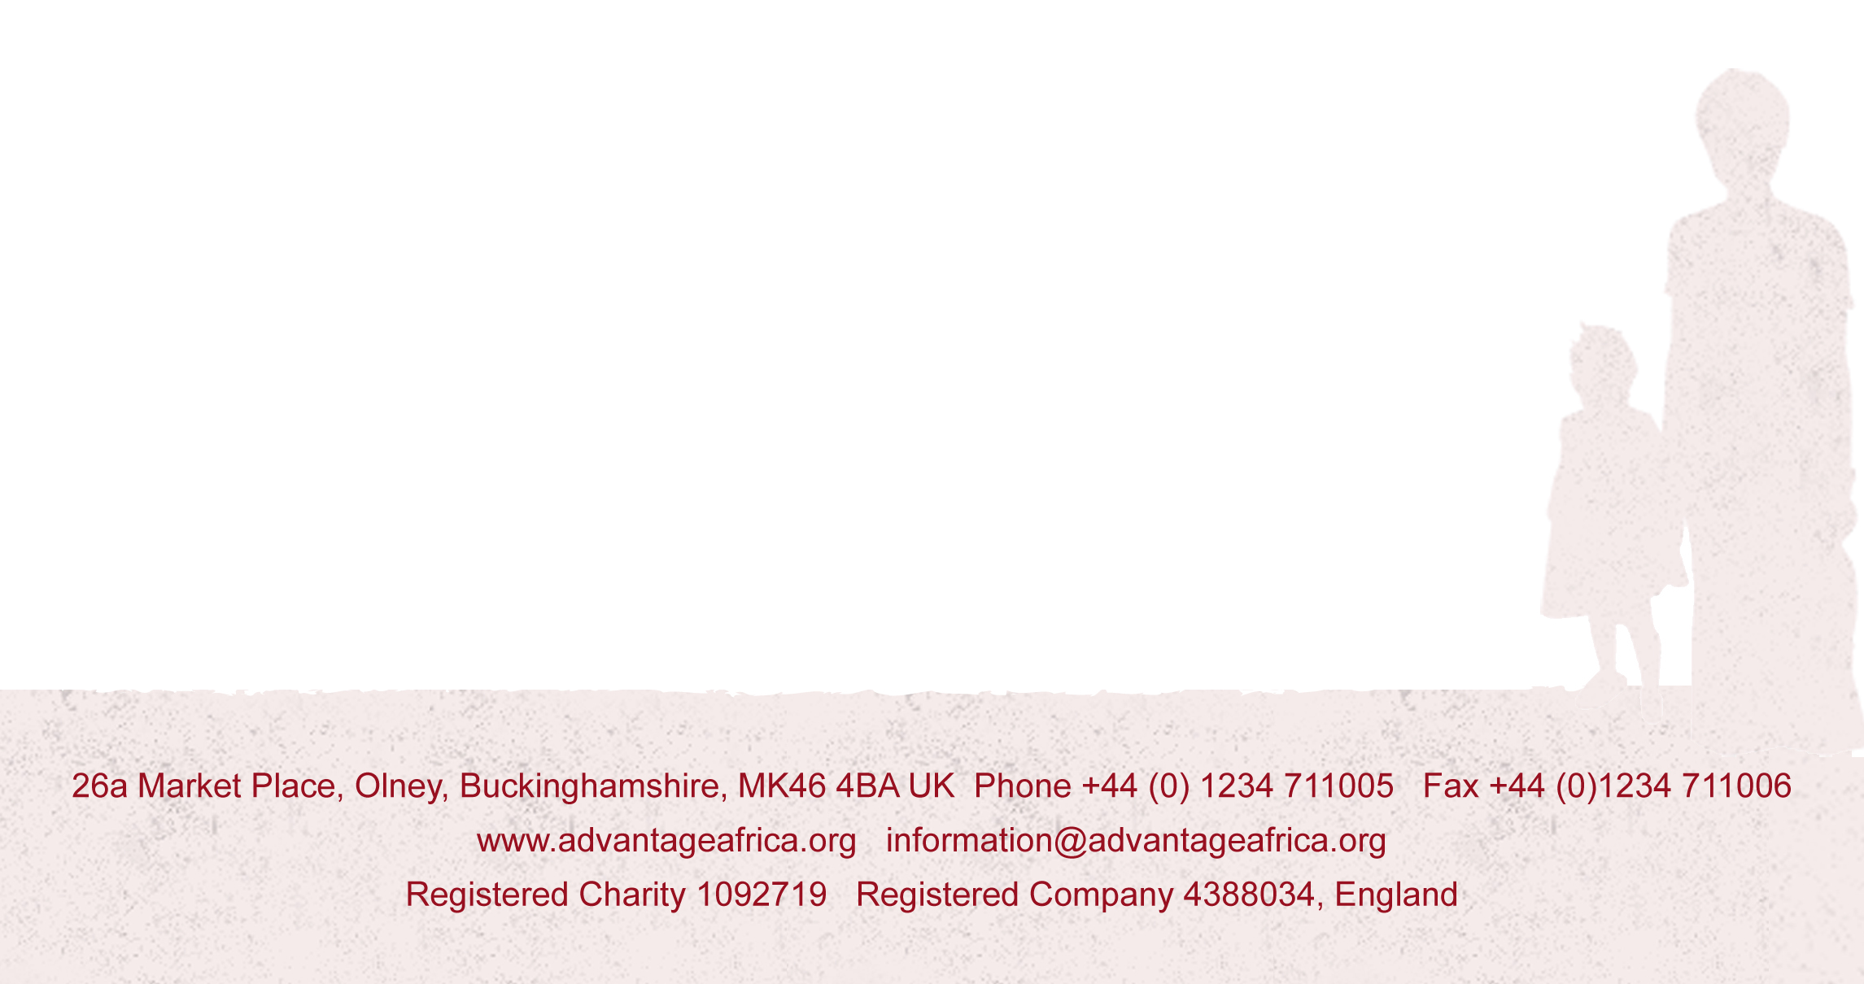
P.S. If any of you are free tomorrow, we’re holding a concert in Olney with a brilliant choir called Heart and Music. More details at http://www.advantageafrica.org/news/2017/06/22/heart-and-music-summer-concert

