Advantage Africa Partners’ Workshop
Handout 9.2 – Impact report example

The Evan Cornish Foundation

Grantee Progress Report

Progress Reports are important as they help you and us to assess whether you achieved what you set out to do in your application, to identify any unexpected results and any learning that we can both use and share.

We are keen for projects to tell us the “whole story” and not just good news. We recognise that for all organisations everything doesn’t always go right, and things sometimes don’t go to plan or don’t work out. This learning is just as important as when things go according to plan and sometimes more so. We encourage you to be as honest as possible in your responses.

Please answer each of the questions as briefly and clearly as possible.

NB: This report is specific to the project you have just undertaken and should not refer to any future application. If you intend to reapply for further funding for this project or another project you will need to apply online at evancornishfoundation.org.uk/how-to-apply

Thank you.

Name of Organisation | Advantage Africa
Date of Award & Value | 11th November 2015
Today’s Date | 29th December 2016

1. | What were the key aims or purposes of the project?  What activities did you undertake in the last year to achieve these aims?
 | KEY AIMS  1. Safeguarding the rights of women and girls (W & G) and supporting survivors of sexual and domestic violence through practical community action. |  | ACTIVITIES UNDERTAKEN  1. Interactive drama to raise awareness of the rights of W&G at community meetings and in schools. These interventions target both potential victims and potential perpetrators.  2. Establishing ‘Local Champions’ who lead the defence of human rights, and form support groups for survivors.  3. Develop and duplicate info-graphic materials to reinforce messages.
2. | Have you achieved what you set out to do?  Please refer to each of the key aims/purposes and activities you outlined in Q1 and tell us when activities were completed and how they went. Please use numbers/hard facts (e.g. number of beneficiaries) where possible. If you have not achieved what you set out to do tell us why. Reflect on any evidence of the quality of the work.  Activity 1. Interactive drama to raise awareness of the rights of W&G at community meetings and in schools. These interventions target both potential victims and potential perpetrators.  This activity was completed very successfully and the original target number of beneficiaries (audience numbers) of 2,300 was exceeded, with a total number of approximately 3,300 people reached by the drama performances, averaging 275 people per event (see details in the table below). The drama group, known as ‘Twaweza’ (Kiswahili for ‘we can’) performed at 12 community and school events during the project year. The Evan Cornish grant facilitated Twaweza’s attendance at 10 of these events, and two were completed from other funds /on a voluntary basis.  The impact of the drama performances was monitored and evaluated by the completion of evaluation questionnaires with a representative sample of about 20 members of the audience after each event. During the project year a total of 239 questionnaires where completed and the analysis of the evaluation data shows very positive impacts for the beneficiary audiences. Details of the data are presented below. In summary it shows that 94% of the total audience rated the drama performances as good or excellent and 98% had understood and learnt from the issues being presented. 88% of respondents also said they would change their behaviour as a result of experiencing the drama performance. Many questionnaire respondents commented that the drama performances tackled important issues about the rights of W&G and should be performed in many more locations. In addition to the formal monitoring data, the project has received very enthusiastic informal feedback, and Twaweza have been invited to perform at other events when resources allow. The group has developed in confidence and commitment and is keen to expand its reach and influence.  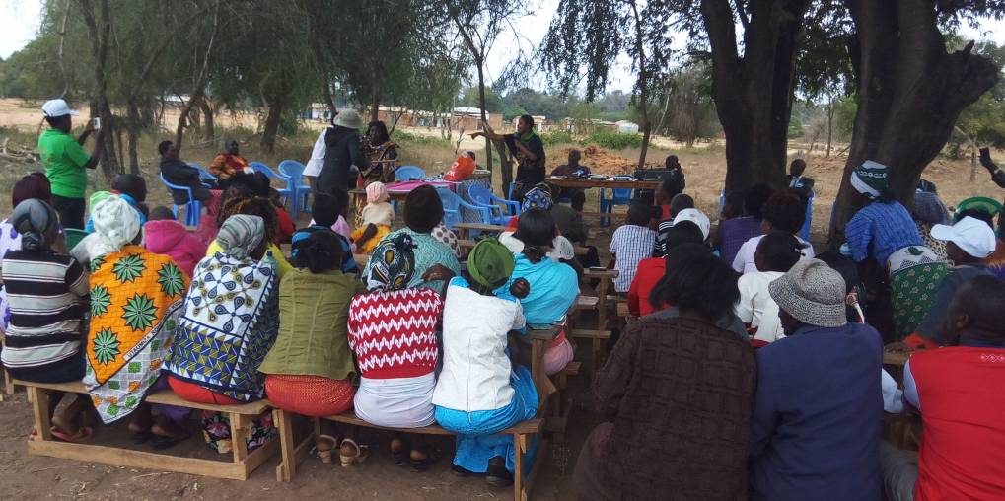  Twaweza performing at a community event  As part of Advantage Africa’s research project on sexual abuse of people with disabilities, Twaweza were given the opportunity to help disseminate our research findings through an advocacy event held at a prestigious venue in Nairobi in November 2016. The performance enlivened the formal proceedings, stimulated vigorous debate and clearly left the audience with a memorable impression of the event.  Activity 2. Establishing ‘Local Champions’ who lead the defence of human rights, and form support groups for survivors.  This activity has been successfully achieved. Agnes Musembi is the Co-ordinator of Kibwezi Disabled Persons’ Organisation and has become a key local champion for human rights in Makueni County of Eastern Kenya. Over the project year she has increased her influence in local lobbying and advocacy initiatives, including nurturing relationships with county government departments. She has been central in pursuing justice for two local survivors of sexual abuse, and has secured two convictions of perpetrators in the last 12 months.  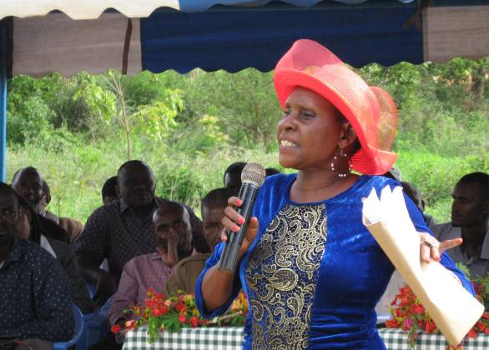  Agnes has also started a local support group for survivors of sexual violence which now has nine members. The members are women with disabilities, six of whom have intellectual disabilities and the others have multiple or hearing impairments. Two group facilitators have been recruited to work with Agnes, one of whom is a local nurse. The group now meets every two months and after building trust between each other during the initial meetings, the members are now disclosing their experiences as survivors of violence and sexual abuse within the confidentiality of the group and are starting to gain strength from one and other. This group is a pilot initiative operating in a setting where professional counselling services do not exist and awareness of the need for psychological support for survivors is weak. The group facilitators and some members would like to undertake training in basic counselling and have identified a possible organisation in Nairobi known as Personal Link Counselling, who can offer this. In future the group would like to expand appropriately to support many more W&G survivors of violence and abuse.  Agnes speaking about human rights at UN International Day for Persons with disabilities  Activity 3. Develop and duplicate info-graphic materials to reinforce messages.  Information sheets were designed to support the issues and messages which were tackled during the drama performances. The sheets were handed out to audience members after each event to act as reference material for beneficiaries and their families. The sheets were designed differently for school and community settings, and used simple language and pictures to convey the issues (See bottom of this section for an example).  Evaluation meeting with beneficiaries  At the end of the project, Advantage Africa’s programme manager, Rob Aley, conducted an evaluation meeting with a small sample of beneficiaries who had witnessed the drama performances. The findings of this meeting confirmed that the Twaweza performances had been very successful in communicating the issues of W&G’s rights in an engaging and memorable way. All of the evaluation meeting participants could remember the narrative of the plays they had seen even though many had witnessed them several months earlier. They strongly confirmed that drama is an excellent medium through which to educate community members, largely because of the aural tradition of information exchange through word of mouth and storytelling. They said ‘drama is a practical way of teaching’ and ‘the audience is understanding because they are seeing’. They suggested the possible filming of a series of short dramas onto a DVDs for wider circulation and to allow screening in more locations.  The group confirmed that they had learnt from the drama and that it had contributed to changes in community attitudes and practices concerning W&G rights. They reported that the problem of violence against W&G now has a higher profile and is being taken as a serious matter. Previously these violations were often dealt with locally between families or with the council of village elders, often resulting in inappropriate outcomes for the survivors. The group said that now the community is beginning to regard these issues with more seriousness and in some cases is taking legal action. One participant said she and others in her village ‘had taken courage and had recently taken a case of child abuse to the police’. They also observed that the drama performances were contributing to a better recognition of human rights issues in general, and that potential violators of rights were being deterred. One participant said ‘the issue is now out in the open, and the perpetrators are now in fear’.  Detailed findings from the evaluation questionnaires (activity 1)  Below are the findings of the evaluation questions completed by a representative sample of about 20 audience members after each drama performance. The total number of respondents in the project year was 239.  Question 1. How would you rate the quality of the acting and drama performance in general?  Excellent 76% (182)  Good 18% (43)  Moderate 2 % (5)  Poor 2 % (5)  No response 2 % (4)  Question 2. What do you think was the main issue / lesson from the drama?  98% of respondents (234) showed from their responses that they had understood the main issue / lesson from the drama. 2% (5) had not understood or did not respond.  Examples of responses to this question were:  Violence against women is an abuse to them (Female 42 yrs)  Family violence does not solve problems but brings more trouble (Male 34 yrs)  I should advise people when they are mistreated (Female 31 yrs)  Home violence (Male 38 yrs)  Beating your wife is an offence (Female 19 yrs)  A woman is not the property of her husband (Female 22 yrs)  Question 3. How successful was the drama in exploring the issue / lesson?  Excellent 69% (165)  Good 29% (69)  Moderate 0%  Poor 2% (5)  Examples of comments to this question were:  It was very clear (Male 42 yrs)  It was very well communicated and understood (Female 26 yrs)  Explored in a unique manner (Male 14 yrs)  The actors brought out the lesson well (Female 22 yrs)  Question 4. Has the drama changed the way you think about the issues (has it changed your attitudes?)  Very much 69% (164)  Somewhat 26% (63)  Not at all 3% (7)  No response 2% (5)  Examples of comments to this question were:  It has made me think legally on respecting children’s rights (Male 29 yrs)  I have understood that human sexuality is to be respected (Male 41yrs)  I earlier thought that women were subject to men, but right now I have understood that men and women have equal rights (Female 38 yrs)  Our cultural way allows for beatings, but I have realised it is not good (Male 34)  No women, even the disabled, should be abused or mistreated (Female 42)  Initially I thought wife beating was something normal but have realised one can be jailed (Male 31)  Question 5. Will you change your behaviour in future because of what you have seen today?  Very much 88% (210)  Somewhat 10% (25)  Not at all 0%  No response 2% (4)  Examples of comments to this question were:  I will not tolerate any more violence (Female 35)  I will take responsibility of preventing children from abuse (Male 37 yrs)  I know it’s abuse if somebody touches your body in places you don’t want them to (Male 18 yrs)  I thought that I would search for a girl to marry after my secondary education, but I will marry after my university education (Male 14yrs)  Table of drama events completed (activity 1)  Example of printed hand-out (activity3)  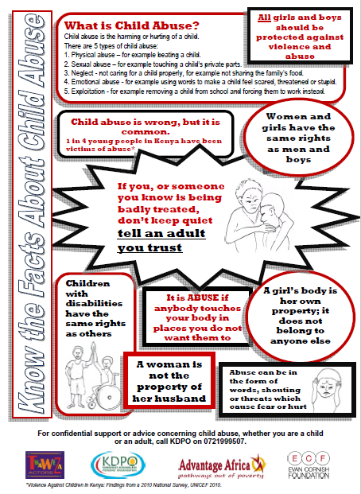
  Event | Estimated total audience | Females | Males | People with disabilities | Age group
  1. Matinga community meeting as part of ‘Compassion’ (INGO) event | 160 | 95 | 65 | 35 | mostly adults
  2. Community meeting at Red Cross Health Centre | 96 | 54 | 42 | 5 | all adults
  3. Kikunga Community - A parent’s visit event | 71 | 43 | 28 | 11 | all adults
  4. Mikuyuni Community event, opening of a dispensary by the county government | 80 | 54 | 26 | 20 | mostly adults
  5. Mbuinzau Community – A pre-wedding event | 100 | 70 | 30 | 14 | adults – children not included in figures
  6. Kwakyai Community – Home coming event | 65 | 43 | 22 | 5 | adults – children not included in figures
  7. Dwa Sisal Plantation Estate community event | 100 | 72 | 28 | 3 | all adults
  8. Masakundogo community ‘Baraza’ (Chief’s meeting) | 150 | 107 | 43 | 39 | mostly adults
  9. Kisayani High School – Prize giving and educational day | 700 | 400 | 300 | 20 | mostly 13-18yrs
  10. Kathiani Primary School – The Head Teacher’s retirement event | 500 | 400 | 100 | 10 | 80% adults and 20% aged 9-14yrs).
  11. Ndetani community ‘Baraza’ (Chief’s meeting) | 81 | 52 | 29 | 21 | mostly adults
  12. Township community – School Fundraising | 1200 | 700 | 500 | 49 | 50% adults  50% 13-18yrs
  Total | 3,303 | 2,090 | 1,213 | 232
3. | What have you learned?  E.g. Did you encounter any difficulties and how did you overcome them? What has gone well or how you might do things differently in the future?  Soon after the project started there were serious problems with student unrest and incidents of arson in over 100 schools across Kenya. Pupils were protesting against conditions and workloads and in some schools classrooms and dormitories were burnt down by the pupils. This situation was widely reported in the international media (eg. http://www.bbc.co.uk/news/world-africa-36845144). These circumstances meant that the Sub County Education Officer in the project location, Mr Kasinbu was on high alert and disinclined to give the necessary permission for the drama group to make the intended visits to schools, an approval process which is normally straightforward. By the time the unrest in schools had abated the pupils were in their third term and concentrating on exams. Therefore the project was unable to make all of the school visits (5) which were in the original plan. However, they did manage to take advantage of two opportunities to secure invitations to schools, one for a Head Teacher’s retirement event and one for a school fundraising day.  Because of the difficulties in accessing schools the project compensated by increasing the number of community events they attended and they therefore managed to exceed the overall target audience numbers, as detailed above.  Other points of note  The impact of the work could be multiplied if local opinion leaders (Village Elders, Chiefs, Assistant Chiefs, Faith Leaders etc.) are sensitised and can reinforce the messages being presented by the drama group.  In future there is a need to include resources for the drama group to devise and rehearse their plays (time and transport costs).  Although we were pleased with the impact of the project, we appreciate that the findings of the evaluation questionnaires are subject to acquiescence bias because the project group were facilitating the evaluations themselves. We tried to mitigate against bias by allowing respondents to fill in the questionnaires anonymously.  We also appreciate that challenging strongly held cultural beliefs in a traditional community is a very sensitive task and can be potentially divisive. We have to balance the advancement of human rights with an understanding of the cultural context in which this work is taking place.
4. | Is the project continuing?  If so, will it be in a similar form or have you incorporated any major changes?  The local project staff and Twaweza actors are totally committed to advancing this work. Their one constraint is funding. Advantage Africa would like the project to continue and develop and will assist in efforts to raise the necessary resources.
5. | Please provide a breakdown of income and expenditure for the work funded against your original budget.  If this differs from your original income and expenditure budget please explain why.  Expenditure was in accordance with the original budget.  Please see attached Excel spreadsheet for details.
Signature |  | 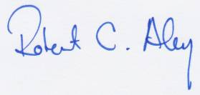
Name |  | Robert Aley
Position in Org |  | Kenya Programme Manager
Email |  | rob.aley@advantageafrica.org
Date |  | 29th December 2016

Please return this completed form via email to the Charity Administrator:
contactus@evancornishfoundation.org.uk

Please send via email wherever possible. If you need to send via post, our mailing address is: The Evan Cornish Foundation, The Innovation Centre, 217 Portobello Sheffield S1 4DP.

www.evancornishfoundation.org.uk

