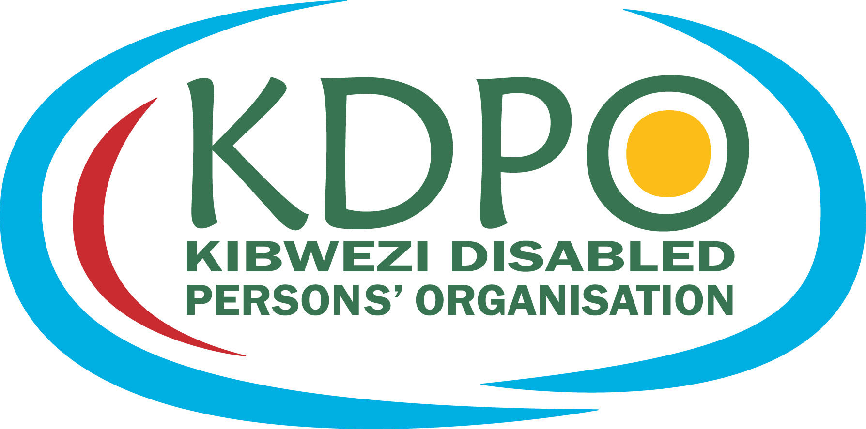
Advantage Africa Partners’ Workshop
Handout 5.1 KDPO Strategic Plan

Strategic Plan Nov 2015- Nov 2018
Written Oct 2015

MAKE SMART

Objective 1. Networking and Marketing of KDPO

KDPO will significantly improve its own marketing and promotion between 2015 and 2017

Activity 1.1
KDPO will maintain and strengthen existing partnerships with:
- Motivation
- Jaipur
- Handicap International Genève (Ulrike)
- Etc –add other partners from flip chart

Activity 1.2
KDPO will start active networking to develop new partnerships with International and national NGOs
SMILE
SIGHTSAVERS
IMPACT (eye and ear school programme)
Latter-Day Saint Charities (LSC) for wheelchairs?
CBM ?

Activity 1.3
KDPO will develop tools and resources for networking and promotion
These will include:
Creation of an active Face book page which is up-dated at lease once a week.
Business Cards for Staff
A printed leaflet describing the Aims, Objectives and achievements of KDPO
At least one banner for exhibitions, workshops and conferences.
KDPO logo T’Shirts.

Objective 2. Local Fundraising

KDPO will be raising 20% of its funds from sources other than Advantage Africa by 2018

Identify potential local / national funding opportunities
Identify personal contacts – corporations and companies
Denmark workers association
National and county Government

Objective 3. Representation, Lobbying and Advocacy

The aim of KDPO concerning Representation, Lobbying and Advocacy is to represent disabled people in decision making forums at Ward, Sub-County and County level. Also with the administration (DC, Chief, sub-chiefs and community leaders) and politicians such the local MP.

KDPO will take up individual cases with the authorities where appropriate. KDPO will also engage in representation and advocacy at the National level in specific instances.

In addition to general representation of disabled people KDPO will periodically champion specific causes; one example is the issue of prevention and responding to Sexual abuse.

Activity 3.1
Organise or be central participants in the UN International Day of Persons with Disabilities event on 3rd Dec in all 3 years of this strategy.

Activity 3.2
Follow-up on pledges of support for disabled people made by the Member of County Assemble for Disability and push for those assurances to be put into action.

Activity 3.3
KDPO will continue to be active in the following forums:
Civic Education Public Participation Office (Agnes)
County Committee (Agnes)
County Board Member –National Woman Representative (Representative for Disability) (Agnes)
Bursaries Committee (Nguli)

Activity 3.4
KDPO will invite County representatives, administration and politicians to suitable events such as trainings.

Activity 3.5
KDPO will continue to empower the 13 village self-help groups to advocate for themselves at community level and beyond.

Activity 3.6
KDPO will choose a variety of appropriate communication methods for advocacy and ensure the relevant resources are ready when needed. These will include business cards, leaflets, banners, T’shirts etc. For advocacy campaigns to mass audiences local and national radio may be used.
The KDPO Drama group will also be used for advocacy and educational activities in various forums. Numbers of performances/ skits/

Activity 3.7

Impacts from Representation, Lobbying and Advocacy will be identified and recorded. For example if the County Government decides to honour commitments as a result of KDPO lobbying.

Objective 4. Provision of Information and Knowledge for Persons with Disabilities

Activity 4.1
KDPO staff to make a major change to their attitudes to information searching and associated work practices as follows:
- Staff will become committed to identifying and collecting useful information.
- Spend time reading and updating professional knowledge from books, internet, email and other sources
- Make better reference to good information when advising clients, and give clients information where appropriate, including language translations.
- Collect information in accessible formats including pictures, diagrams, audio etc.

GRANARY

Activity 4.2
Appropriate KDPO staff to be trained in practical ways to collect, adapt, categorise and store useful information (Kariuki to identify trainer).

Purchase a computer for the resource centre, and a back-up hard drive (and or Cloud back-up) (when funds available)

Activity 4.3
Create a resource centre in the KDPO office (Bookshelves and Computer Based information) and organise and categorise the information. Ensure it is well organised and well maintained. Collect the first 50 information sources (books / print outs/ websites / CDs etc) Advantage Africa to assist with sourcing good information.

Yr 2 Complete the establishment of a well organised and useful resource centre. Use information from the resource centre with at least 30 clients in year 2.

Yr 3 Use information from the resource centre with at least 80 clients in year 3.

Objective 5. Self- reliance through income generation and employment

Activity 5.1
Income generation for Individuals

KDPO will continue to facilitate disabled people to start and run their own income generating activities. Where appropriate they will also assist disabled people to access vocational training formal employment.

The following principals will be used when identifying beneficiaries for IGAs and Small businesses.
- Identify beneficiaries that have shown commitment and/or skill in the chosen type of business
- Identify IGA start-up ideas which do not need a lot of investment to start and have a strong market and a good plan.
- To minimise risk of start-up failures - identify IGAs that are understood and normal in the Kamba community (eg. Poultry and goat keeping) Unfamiliar activities need a lot more training and are more risky

Activity 5.2
Year 1. Build on the successes of the poultry and Chicken keeping training / IGA start-ups by distributing the off-spring (chicks and young goats) from the first set of beneficiaries, to new beneficiaries.

Identify possible new funders to repeat the Charles Hayward funded project with another group of disabled beneficiaries. Make at least 2 funding applications for this in year 1, with assistance from Advantage Africa.

In year one also assist between 5 and 10 individuals with other small business start-ups, for example tailoring for those that already have skills.

Continue to make follow-ups to those beneficiaries who have been assisted to start-up IGAs / small businesses.

Year 2.
Implement a new IGA project with funds raised in year 1 for about 50 to 60 new beneficiaries.

Year 3 plan to be made depending upon the successes of years 1 and 2

Income generation for groups

At the start of this plan (Oct 2015) there are 13 village disabled persons groups that have been instigated and supported by KDPO.

KDPO will continue to encourage these groups to work together on income generation while also ensuring that the activities are arranged to allow for individual rewards based upon effort. This is a principle which will avoid disagreements and disputes within groups.

Continue to support 13 groups with IGAs in year 1, 2 and 3. Do not increase the number of group IGAs but instead ensure that the existing groups continue to run their IGAs successfully.

Objective 6. Rehabilitation Services

Facilitate access to medical assistance and surgery for PWDs who can benefit and are keen to access medical assistance.

Activity 6.1. Surgery / Medical Services

Year 1 – Maintain and identify new partnerships with potential partners that can provide medical services to KDPO clients,
including:
Maintaining partnership with Makindu Hospital.

Identifying other partners / medical service providers
Specifically explore partnerships with:
SMILE
SIGHTSAVERS
IMPACT (eye and ear school programme)
CBM ?

Target for number of surgeries Year 1, 10 people. Year 2, 15people. Year 3, 25people

Activity 6.2 Rehabilitation / Drug therapy advice and referrals.
Identify training for KDPO and relevant clients in up-to-date epilepsy drug therapy and associated issues. (Possibly through KAWE Kenya Association for the Welfare of Epileptics)
Provide better referral and follow-up services for people with epilepsy
Keep more up-to-date concerning new information in the field of community based rehabilitation generally - practice and services.

Activity 6.3 Prosthetics and Appliance Services

Develop existing Partnership with Motivation to improve wheelchair referrals and services and the number of clients benefiting from mobility equipment. Kariuki and Nguli/Ndolo to try to get places on Motivation basis wheelchair assessment and fitting course.

Continue to improve the quality of KDPO rehabilitation workshop products by:
- Continually to be careful to make good assessments of client’s needs.
- Making more durable products, especially by switching from wood to metal construction for items such as crutches, walking and standing frames.
- Providing good accessories such as high density wheelchair and seating cushions..
- Where possible increase the adjustability of products such as children’s crutches.
- Continue to improve the finish and attractiveness of finished products with colour and good paint finishes.

Continue to up-date the KDPO workshop staff (Ndolo and Nguli) skills in modern techniques and new approaches and technologies.
Including possible visit to CoRSU (Community Rehabilitation Services Union?) in Entebbe

Objective 7. Education of Children with Disabilities

- Maintain and develop the partnership with Mikuyuni Primary school and use it as an example of good practice for other schools.
- Where possible match out of school children with local schools and assist parents with enrolment and schools. Help schools (and administrators) to understand the rights of children with disabilities and schools obligations to achieve education for all. Help them understand and support special pupils’ needs.
- Consider in more detail the issue of disabled pupils going to / from school and how this could be helped at community level.
- Continue to lobby at county level for school fees payments for disabled children.
- Arrange an exchange visit to Mitaboni and Thinu Special units particularly to learn about transition from school to home community for school leavers.
- Explore what other organisations have learnt in the field of special education including Sight Savers and Handicap International

Objective 8. Responding to severe hardship and emergencies

KDPO will keep a small fund available to respond to clients that experience severe hardship and emergencies, such as urgent housing repairs, medical help etc.

-------------------------------------------------------------------------------------------------------------------

More objectives on:
9.SEXUAL ABUSE
inc DRAMA GROUP

10.HOME VISITS AND VISITS TO GROUPS
11. KDPO administrative and management skills

Add in
How to Monitoring/evaluation for each objective

National Bodies
KAWE
ASK – Albinism Society of Kenya
For Blind
For Deaf
APDK

