**Advantage Africa Partners’ Workshop**

**Handout 12.3 Analysed Cash and Bank Book Practice**

1. Use the information below to complete the analysed bank and cash book for the fictitious organisation *Training for Development.*

Some of the information has already been included

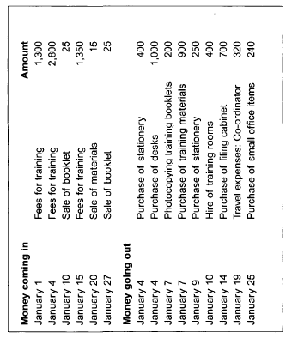 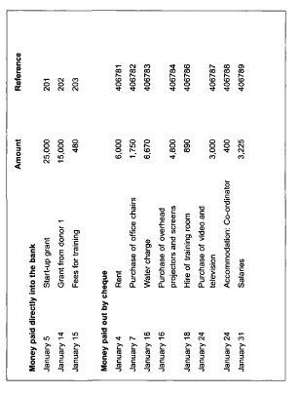

***Training for Development* analysed cash and bank book (income side)**

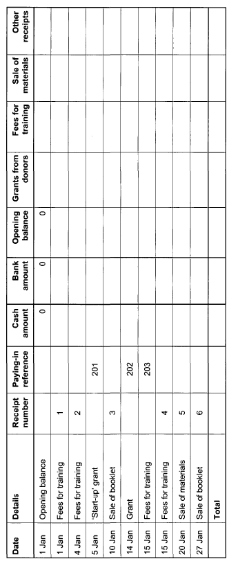

***Training for Development* analysed cash and bank book (expenditure side)**

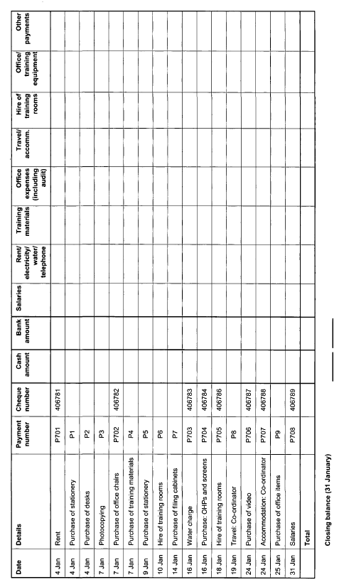

2. In February, Training and Development had the following transactions. Record these transactions in the cash and bank book below

